**Project Report on.**

Submitted By :

**GARIMA MAHATO**

**B.Tech**

**5th Semester**

ACKNOWLEDGMENT

The satisfaction that accompanies the successful completion of any task would be incomplete without the mention of people who make it possible & whose constant guidance and encouragement crowns all the efforts with success. The acknowledgement transcends the reality of formality when we would like to express deep gratitude respect to all those people behind the screen who guided, inspired and helped us for the completion of my Project work.

ACKNOWLEDGMENT

The satisfaction that accompanies the successful completion of any task would be incomplete without the mention of people who make it possible & whose constant guidance and encouragement crowns all the efforts with success. The acknowledgement transcends the reality of formality when we would like to express deep gratitude respect to all those people behind the screen who guided, inspired and helped us for the completion of my Project work.

**Project Report on.**

Under the guidance of

EXTERNAL GUIDE

Ms. Bipasha Sanyal

Trainer, IBM

Submitted By :

**KUMARI DEEPSHIKHA**

**B.Tech**

**5th Semester**

ACKNOWLEDGMENT

The satisfaction that accompanies the successful completion of any task would be incomplete without the mention of people who make it possible & whose constant guidance and encouragement crowns all the efforts with success. The acknowledgement transcends the reality of formality when we would like to express deep gratitude respect to all those people behind the screen who guided, inspired and helped us for the completion of my Project work.

CONTENTS

1. Synopsis

2. Introduction

3. System Analysis

3.1. Existing System

3.2. Proposed System

4. Feasibility Report

4.1. Technical Feasibility

4.2. Operational Feasibility

4.3.Economical Feasibility

5. System Requirement Specifications Document

5.1. Overview

5.2. Modules Descriptions

5.3. Abbreviations

5.4. References

5.5. Product Perspective

5.6. Software Interface

5.7. Hardware Interface

5.8. Communication Interface

5.9. Technologies

5.10. Product Functions

5.11. User Characteristics

5.12. Constraints

5.13. Assumptions and dependencies

6. Spiral Model software development Methodology

7. System Design

7.1. E-R Diagram

7.2. Data Flow Diagram

7.3. UML Diagram

7.4. Data Dictionary

8. Project Module Description

9. Testing

10. Future Enhancement

11. Conclusion

12. Bibliography

Synopsis – Online National Polling

|  |  |  |
| --- | --- | --- |
|  | **Name of the Project** | Online National Polling |
|  | **Objective/ Vision** | Creating and maintaining web portal to entertain the Democracy of any State or Country by making the election process easier and easy to reach to the common people or mass of that State. The system will help to minimize the Complexity of the Election process and will help to minimize the time and money spent for the Election process. It will also help to minimize the Corruption and Duplicate Voting during the Poll. |
|  | **Users of the System** | * Voter * Candidate * System Administrator * Field Officer |
|  | **Functional Requirements**  **(Atleast Eight)** | **Provide role based access to the system**   1. **Voters :** The Voters are the end-users with privileges to   Login to the system.  Casting Vote.  Participate in discussion forums with other voters, candidates  View voting results  Lodge complaints for frauds during voting  **2. Candidate :** The Candidates are the end-users with privileges to  Login to the system.  Casting Vote.  Maintain party and candidate details  Interact with people thru mails, chats, blogs, messages.  **3. Field- officer :** The Field officer be able to  Login to the system.  Manage system.  Manage Log activity.  Publish the status.  Lodge complaints for frauds during the voting  **4. Election Commissioner:** The Commissioner be able to  Managing Login Process.  Administer the system.  Maintain Candidate details  Restore data.  Backup data. |
|  | **Non-functional requirements (Atleast Four)** | * i. Secure access of confidential data (user’s details). SSL can be used. * ii. 24X7availability * iii. Better component design to get better performance at peak time * iv. Local language support is required * v. Interface with existing Voter database to validate the voter by fetch biometric identification details. |
|  | **User interface priorities ( required for Embedded projects )** | Not Required |
|  | **Tools and Technologies to be used** | 1. UML diagrams using Rational RSA7.5 2. Web-Sphere Application Server tool-kit which serves dual purpose i.e as an IDE as well as an application server.   3. Database management using DB2 |

INTRODUCTION

India has an asymmetric [federal government](http://en.wikipedia.org/wiki/Federalism), with elected officials at the federal, state and local levels. At the national level, the [head of government](http://en.wikipedia.org/wiki/Head_of_government), [prime minister](http://en.wikipedia.org/wiki/Prime_Minister_of_India), is elected by the members of [Lok Sabha](http://en.wikipedia.org/wiki/Lok_Sabha" \o "Lok Sabha), lower house of the parliament of India. All members of Lok Sabha except two, who can be nominated by president of India, are directly elected through general elections which take place every five years, in normal circumstances, by [universal adult suffrage](http://en.wikipedia.org/wiki/Universal_suffrage). Members of [Rajya Sabha](http://en.wikipedia.org/wiki/Rajya_Sabha" \o "Rajya Sabha), upper house of Indian parliament, are elected by elected members of the legislative assemblies of states and Electoral college for Union Territories of India.

An examination, however, is not always a true test of merit. This is true of elections as well. Even bad persons very often win and good persons lose, why? Our voters do not know the importance of vote. A ballot paper we know is not just a piece of paper. It is a very powerful weapon. It changes a government without shedding even a drop of blood. But do the people always make a right use of their ballot paper? No not always. They vote for a candidate in the name of some group or caste. Their poverty, too, does not allow them to use their vote well. How can poor people remain honest and not be bribed? So, our elections are neither completely free nor fair.

Nowhere around the country only a fraction of population go for voting in their territory.

There are many reasons for that some of them are:

• In the rural areas the influential people keep their men at the polling booths to threaten the

common man to vote for them

• There are many portions of the country like the North East where there is locally sponsored

Terrorism, at such places the security conditions is also not very bright, so naturally people

scared of going outside and giving vote.

• Net savvy new generation want hassle free voting system. Also the people in metros want a

system through which they can vote for their territory without traveling.

Keeping in mind these situations and to improve the state of democracy in the country Online

Polling System can be thought as a solution, in conjunction with the ongoing current manual

voting system.

SYSTEM ANALYSIS

**Existing System**

* It is manual system.
* Complexity in Management of Polling Station.
* The existing system may not provide security to Polling Station.
* Maintain nominee, filed officers, user details is risky tasks.
* This system is not providing secure registration and profile management of all the users properly.

**Proposed System**

The development of this new system contains the following activities, which try to automate

the voting process keeping in the view of database integration approach.

* Automates information related to polling stations.
* Avoid mismanagement (verify users profiles, accept, reject users).
* We can maintain all types of user details properly.
* Rich user interface.

FEASIBILITY STUDY

**FEASIBILITY REPORT:**

* **TECHNICAL FEASIBILITY:**

Evaluating the technical feasibility is the trickiest part of a feasibility study. This is because,

at this point in time, not too many detailed design of the system, making it difficult to access

issues like performance, costs on (on account of the kind of technology to be deployed) etc. A

number of issues have to be considered while doing a technical

analysis.

1. **Understand the different technologies involved in the proposed system:**

Before commencing the project, we have to be very clear about what are the

technologies that are to be required for the development of the new system.

1. **Find out whether the organization currently possesses the required technologies:**
   * Is the required technology available with the organization?
   * If so is the capacity sufficient?

For instance –

“Will the current printer be able to handle the new reports and forms required for the

new system?”

* **OPERATIONAL FEASIBILITY:**

Proposed projects are beneficial only if they can be turned into information systems that will

meet the organizations operating requirements. Simply stated, this test of feasibility asks if

the system will work when it is developed and installed. Are there major barriers to

Implementation? Here are questions that will help test the operational feasibility of a project:

manual system, the new system was considered to be operational feasible.

1. Is there sufficient support for the project from management from users? If the current system is well liked and used to the extent that persons will not be able to see reasons for change, there may be resistance.
2. Are the current business methods acceptable to the user? If they are not, Users may welcome a change that will bring about a more operational and useful systems.
3. Have the user been involved in the planning and development of the project?
4. Early involvement reduces the chances of resistance to the system and in
5. General and increases the likelihood of successful project.

Since the proposed system was to help reduce the hardships encountered. In the existing

manual system, the new system was considered to be operational feasible.

* **ECONOMIC FEASIBILITY:**

Economic feasibility attempts 2 weigh the costs of developing and implementing a new

system, against the benefits that would accrue from having the new system in place. This

feasibility study gives the top management the economic justification for the new system.

A simple economic analysis which gives the actual comparison of costs and benefits are

much more meaningful in this case. In addition, this proves to be a useful point of reference

to compare actual costs as the project progresses. There could be various types of intangible

benefits on account of automation. These could include increased customer satisfaction,

improvement in product quality better decision making timeliness of information, expediting

activities, improved accuracy of operations, better documentation and record keeping, faster

retrieval of information, better employee morale.

SYSTEM REQUIREMENT

SPECIFICATION

**OVERVIEW**

The aim of this project is to create and manage online polling and election

System Online that contain all the details of election and every person related

to it from voter to election commissioner. It contains all the detail before the

start of election to the announcement of result. It contains-

1. Appointment of Field Officer in different areas.

2. Voter’s registration, verification, and publishing of voter Id

3. Candidate’s registration, verification.

4. Announcement of election date,

5. Publishing result Announcing winner.

6. Providing interface between voter and candidate and many

more things.

**STUDY OF THE SYSTEM**

In the flexibility of uses the interface has been developed a graphics concepts

in mind, associated through a browser interface. The GUI’s at the top level has

been categorized as follows

1. Commission User Interface Design.
2. Field Officer User Interface.
3. Applied Candidate User Interface.
4. General User/Voter Interface.
5. Reports User Interface.

**Number of Modules**

1. Commissioner and Field Officers Modules
2. Users Registration Modules
3. Constituency Modules
4. Party and Nominations Modules
5. Election and result Modules

**MODULES DESCRIPTIONS:**

1. **Commissioner and Field Officers Modules:**

In this module the role of commissioner is to maintain the field officers by taking

of his/her profile details like user name, date of birth ,address, constituency,

contact ,designation ,department ,qualification and take responsibility of users

request same as above mentioned to make forward to field officers and he has

privileges to accept or reject the users details based on age details and in some

situations he mentioned qualification details include applied candidates requests

who can participates in election.

1. **Users Registration Modules:**

This module a general user is willing to participates in voting then first he has to

make request to commissioner by filling registration form with these variables

like user name, date of birth, address, constituency, contact number, guardian’s

name, department, qualification. After getting the permissions he will get a

username, password, using that username, password he/she attends in election.

1. **Constituency Modules :**

In this specified module the commissioner is enter the details of each

constituency. Total area is divided into different constituencies depend on

environment and here commissioner collect the each constituency details,

district, pin, state etc. to select the nominated persons.

1. **Party and Nominations Modules**

In this election the candidates/nominees whose participating in election may

belong to a particular party and each party contain its own party name, party

in charge, party symbol, agenda/manifesto and campaigns start date, campaigns

end date with respect the constituency. The persons(nominated) who participating

in election may belongs to party.

1. **Election and Result Modules**

In this module nominated peoples are participating in election by getting details

of election notification election type, election start date, election end date,

election in charge, nomination start date, nomination end date and based on the

values the general peoples are who has already take election membership will

participates in polling the nominated person will be elected based on election

polling count mean those members are select more by polling.

**ABBREVIATIONS:**

**HTML:** Hypertext Markup Language is a markup language used to design static web pages.

**EJB:** Enterprise Java Beans.

**J2EE:** Java 2 Enterprise Edition is a programming platform— part of the Java

Platform—for developing and running distributed multitier architecture Java

applications, based largely on modular software components running on an

application server.

**DB2:** DB2 is the database management system that delivers a flexible and Cost

effective database platform to build robust on demand business applications.

**WAS:** Web sphere application server is an application server that runs business

applications and supports the J2EE and web services standards.

**HTTP**: Hypertext Transfer Protocol is a transaction oriented client/server protocol

between web browser & a Web Server.

**REFERENCES:**

|  |  |  |
| --- | --- | --- |
| S.No. | Document Title/Book | Source/Author |
| 1. | IEEE SRS Format | Google Search Engine |
| 2. | Project Scenario | CEIS Project |
| 3. | SRS Format | IBM Developer Works |
| 4. | Software Engineering | Rajiv Mal |
| 5. | Database System  Concepts | Abraham Silberschatz  Henry F. Korth  S. Sudarshan |

COMPLETE PRODUCT ENVIRONMENT



Here is the short description of product

1. The HTTP server serves static web pages to the server.
2. The web Sphere application server plugs into the HTTP server for dynamic content

Generated by servlets and java web pages.

1. Visual age for java is the product for development and testing of java applications,

Applets, servlets, java beans and Enterprise java beans. It also include the web Sphere

Test environment.

1. Web sphere Studio provides a development environment for HTML files and JSPs.

It also provides wizard that generates skeleton web pages, web pages, servlets and jsp

For database and java bean access.

1. Web applications can access enterprise resources such as DB2, CICS, MQseries

IMS, SAPs and other through connectors.

1. PRODUCT IN OUR DEVELOPMENT ENVIRONMENT



1. **PRODUCT PERSTECTIVE:**

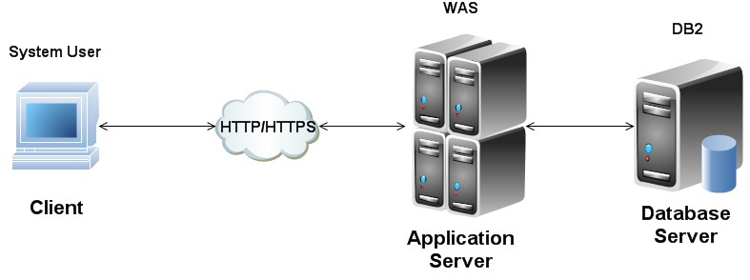

1. **COMPONENT FLOW**



**SOFTWARE INTERFACE:**

Operating System : Windows 8

User Interface : HTML, CSS

Client-side Scripting : JavaScript

Programming Language : Java

Web Applications : JDBC, Servlets, JSP

IDE/Workbench : Web Sphere Application Server Toolkit

Application Server : Web Sphere Application Server V7.1

Database : IBM DB2 V9.1

**HARDWARE INTERFACE:**

|  |  |  |  |
| --- | --- | --- | --- |
| **Client side** | | | |
|  | Processor | Ram | Free Disk Space |
| Web Browser (any) | Intel Core i3 | 4 GB | 100 MB |
| **Server side** | | | |
| Web Sphere Application  Server (Community  Edition) | Intel Core i3 | 4 GB | 1 GB |
| DB2 Express-c V9.7 | Intel Core i3 | 4 GB | 1 GB |

**COMMUNICATION INTERFACE:**

* Client on Internet will be using HTTP/HTTPS protocol.
* **TECHNOLOGIES:**

1. **J2EE:** (Servlet, JSP, Java Beans) Application architecture.
2. **JAVA:** Application architecture.
3. **WASCE:** (Web Sphere Application Server Community Edition) Web Server
4. **DB2:** IBM Database.

**AST** **:** Development tools

1. **Localization:** Language - English

**Technological Details:-**

Here is a short description of the major components of WAS:

❑WAS contains a plug-in for many HTTP servers, including the IBM HTTP Server.

❑WAS runs on a node (a TCP/IP host name).

❑JDBC drivers and Data Sources describe how relational databases are accessed from

servlets.

❑Multiple servers (for example, the Default Server), each with a servlet engine , run on the

node.

❑Servlets and JSPs are grouped into Web applications. A server contains multiple Web

applications.

❑An administrative console program maintains the configuration of the application Server in

a DB2 (or Oracle) database. The configuration contains information about servers, Web

applications, servlets, EJBs, the JSP compiler, Data Sources, and other resources.

❑The right side of the diagram shows the directory structure for the HTTP server and the

Application Server. The HTTP Server directory contains static HTML files. The Application

Server directory contains the directories for the Web applications, such as the default

application and any user defined Web applications. For each Web application there is

normally a servlets and a web subdirectory.

• The servlets subdirectory contains executable code for servlets and JavaBeans.

• The web subdirectory contains HTML and JSP files. HTML files are served to a browser

by a special file handling servlet. JSP files are compiled into servlets the first time they are

invoked.

❑The code in Web applications can access enterprise resources, such as relational databases

(DB2 and others), CICS, MQSeries, IMS, SAP, and others. This is normally done using the

Common Connector Framework



**FEATURES OF WAS :**

1. Protect investment by allowing you to service-enable existing packaged and legacy

application ;create new services and extend your business application to the web

1. Fully utilize diverse developer skills with a comprehensive set of open standard-based

programming models: CEA, JPA, SAML, SDO, SIP, Web 2.0, and XML

1. Run the same amount of workloads on fewer server by consolidation up to 30 % of

Workload utilizing EJB and Web service performance enhancing features

1. Prevent costly security breach exposures with security domain that deliver granular & flexible control
2. Dramatically increases development productivity with integrated tooling and unique backward compatibility features that eliminate recording.

The Web Sphere Application Server drives business agility by providing millions of developers and IT Architecture with an Innovative, performance-based foundation to build, reuse, run, integrate and manage Service Oriented Architecture (SOA) application and services. From business critical and key enterprise-wide applications to the smallest department level applications, Websphere Application Server Offers the highest level of reliability and agile business applications: Simplified Development, High Performance and Intelligent Management.

Following are the flagship features of Web Sphere Application Server Version 7:

1. **Flexible Management**

Flexible Management facilitates administration of a large number of WebSphere Application Server base edition and Network Deployment topologies that might be geographically distributed.

1. **Business-Level Application**

Business-Level Application is used for managing application artifacts independent of packaging or programming models.

1. **Property Based Configuration**

The Property Based Configuration feature simplifies the experience of automating administration: an administrator can update the WebSphere Application Server Version 7 configuration using a simple property file.

**Version 8.0 (Beta)**

1 Beta Refresh was released on October 18, 2010. 2 Beta Refresh was released on March 11, 2011.

It promises to be a [Java EE](http://en.wikipedia.org/wiki/Java_Platform,_Enterprise_Edition) 6 compliant application server.

**WebSphere Extended Deployment**

WebSphere Application Server V6 Extended Deployment Edition (WebSphere XD) was released in 2006 as an add-on for WebSphere 6. XD provides advanced features for both administrators who manage multiple Java EE-based applications and developers building advanced applications that require asymmetric clustering techniques. It also has a number of technologies to significantly increase the performance of running applications, including an in-memory database cache and a highly advanced load balancer called the *on demand router*.

**Security**

The WebSphere Application Server security model is based on the services provided in the operating system and the [Java EE](http://en.wikipedia.org/wiki/Java_Platform,_Enterprise_Edition) security model. WebSphere Application Server provides implementations of user authentication and authorization mechanisms providing support for various user registries:

1. Local operating system user registry
2. [LDAP](http://en.wikipedia.org/wiki/Lightweight_Directory_Access_Protocol) user registry
3. Federated user registry (as of version 6.1)
4. Custom user registry

The authentication mechanisms supported by WebSphere are

1. [Lightweight Third Party Authentication](http://en.wikipedia.org/wiki/IBM_Lightweight_Third-Party_Authentication) (LTPA)
2. [Comparison of application servers](http://en.wikipedia.org/wiki/Comparison_of_application_servers#Java_EE)

WebSphere Application Server provides the flexibility, efficiency and intelligent management that an agile, cost-effective business requires Speed the delivery of applications and services, operate efficiently and reliably and ensure security and control with IBM WebSphere Application Server.

1. Reduce costs through high performance to consolidate workloads, infrastructure and administrative tasks
2. Improve end-user experiences through rapid delivery of innovative applications
3. Utilize diverse developer skills using comprehensive open standards-based programming models, including Java EE 6, OSGi Applications, Web 2.0 and Mobile, Java Batch, XML, Service Component Architecture (SCA), Communications Enabled Applications (CEA), Session Initiation Protocol (SIP) and Dynamic Scripting.
4. Achieve higher application security with flexible and granular control.
5. Manage geographically dispersed applications centrally to cut the cost of administration.
6. Maintain transaction integrity, overall reliability and scalability, and reduce downtime with industry leading quality of service.
7. Reduce downtime with enhanced Web server load balancing and failover
8. Optimize costs with a variety of pricing alternatives including availability of optional [socket-based pricing](http://www.ibm.com/common/ssi/cgi-bin/ssialias?subtype=ca&infotype=an&appname=iSource&supplier=897&letternum=ENUS210-310).
9. Maximize developer productivity with unique backwards compatibility features that eliminate recoding and through separately available integrated IBM Rational Application Developer tooling.
10. Reuse and extend legacy and packaged applications to reduce costs, which can be further accelerated using the optionally available IBM WebSphere Adapters V7.5.

**WEBSPHERE APPLICATION SERVER TOOLKIT:**

The Application Server Toolkit is built using Eclipse v3.0 technology with features for team programming, debugging,J2EE application deployment and more. Eclipse is an open and industry-supported platform for development tools. The application Server Toolkit also provides a familiar interface extend with the Rational Developer family of products. Those products extend the capability of the Application Server Toolkit, such as supporting the creation of new applications.

**DB2 :**

The **IBM DB2** Enterprise Server Edition is a [relational model](http://en.wikipedia.org/wiki/Relational_model) [database server](http://en.wikipedia.org/wiki/Database_server) developed by [IBM](http://en.wikipedia.org/wiki/IBM). DB2 provides an [open](http://www.webopedia.com/TERM/O/open.html) database environment that runs on a wide variety of computing platforms. A DB2 database can grow from a small single-user application to a large [multi-user](http://www.webopedia.com/TERM/M/multi_user.html) system. Using [SQL](http://www.webopedia.com/TERM/S/SQL.html), users can obtain data simultaneously from DB2 and other [databases](http://www.webopedia.com/TERM/D/database.html). DB2 includes a range of application development and management tools. It primarily runs on [Unix](http://en.wikipedia.org/wiki/Unix) (namely [AIX](http://en.wikipedia.org/wiki/AIX)), [Linux](http://en.wikipedia.org/wiki/Linux), [IBM i](http://en.wikipedia.org/wiki/IBM_i) (formerly [OS/400](http://en.wikipedia.org/wiki/OS/400)), [z/OS](http://en.wikipedia.org/wiki/Z/OS) and [Windows](http://en.wikipedia.org/wiki/Microsoft_Windows) servers. DB2 also powers the different IBM InfoSphere Warehouse editions. Alongside DB2 is another [RDBMS](http://en.wikipedia.org/wiki/Relational_database_management_system): [Informix](http://en.wikipedia.org/wiki/Informix), which was acquired by IBM in 2001.

**Technical information:**

DB2 can be administrated from either the command –line or a GUI .The command line interface require more knowledge of the product but can be more easily accepted & automated. The GUI is multiplatform java clients that contain a variety of wizard suitable for novice user. DB2 supports both SQL & X Query.

DB2 has APIs for REXX, RPG, COBOL, FORTAN, C++ and many other programming language .DB2 also support integration into the Eclipse & Visual Studio.NET integration development environment.

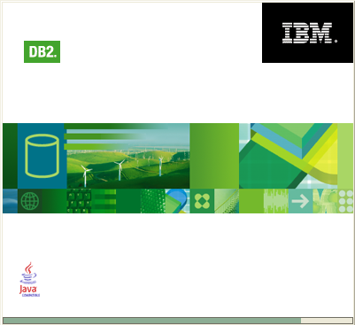**Features DB2:**

Welcome to the DB2 Information Center The DB2(R) Information Center gives you access to all of the information that you need to use the DB2 Information Management family of products and features for Linux, UNIX, and Windows operating systems.

|The current documentation is at the following level: *version* DB2 Data Warehouse Edition Version 9.1.

**DB2 Data Warehouse Edition V9.1 overview**

DB2 Data Warehouse Edition (DWE) is a suite of products that combines the strength of DB2 Universal Database™ (DB2 UDB) with the powerful business intelligence infrastructure from IBM®. DB2 Data Warehouse Edition provides a comprehensive business intelligence platform with the that tools your enterprise and partners need to deploy and build next generation analytic solutions.

You can use DWE to build a complete data warehousing solution that includes a highly scalable relational database, data access capabilities, business intelligence analytics, and front-end analysis tools. DWE integrates core components for warehouse administration, data mining, OLAP and inline analytics and reporting.

The following products are provided in DB2 Data Warehouse Enterprise Edition:

1. DWE Design Studio, which includes a subset of IBM Rational® Data Architect.
2. DWE SQL Warehousing Tool.
3. DWE Administration Console.
4. DB2 Universal Database™ Enterprise Server Edition, Version 8.2 Fix Pack 3 (Version 8.1 Fix Pack 10), which includes the DB2® Data Partitioning Feature.
5. DWE Cube Views™, Version 8.2 Fix Pack 3 (Version 8.1 Fix Pack 10). The OLAP Center in Cube Views is the previous-generation user interface and is included in DWE Version 9.1 to provide continuity for existing customers who can transition to the DWE Design Studio and DWE Administration Console at their convenience.
6. DB2 Query Patroller, Version 8.2 Fix Pack 3 (Version 8.1 Fix Pack 10).
7. DWE Intelligent Miner™.
8. DB2 Alphablox, Version 8.4, and its documentation.
9. DWE Version 9.1 documentation, which is combined with the DB2 UDB documentation in an Information Center.
10. WebSphere® Application Server Version 6.0.2.

The following products are provided in the DB2 Data Warehouse Base Edition:

1. DB2 Universal Database Enterprise Server Edition, Version 8.2 Fix Pack 3 (Version 8.1 Fix Pack 10)
2. DWE Cube Views, Version 8.2 Fix Pack 3 (Version 8.1 Fix Pack 10)
3. DWE Design Studio, with plug-ins for Rational Data Architect and Cube Views™ only
4. DWE Version 9.1 documentation, which is combined with the DB2 UDB documentation in an Information Center

In Version 9.1, the following components are not included in DWE:

1. DB2 Warehouse Manager
2. DB2 Information Integrator
3. DB2 Office Connect

The following sections provide a general overview of the products that are included in the Enterprise and Base editions of DWE.

1. [**DWE architecture**](http://publib.boulder.ibm.com/infocenter/db2luw/v8/topic/com.ibm.datatools.olap.ui.doc/dwe91arch.html)  
   DWE has a component-based architecture with client and server pieces.
2. [**DWE components**](http://publib.boulder.ibm.com/infocenter/db2luw/v8/topic/com.ibm.datatools.olap.ui.doc/dwe91design.html)  
   The DWE components provide an integrated platform for warehouse administration and for developing warehouse-based analytics, including Web-based applications with embedded data mining and multidimensional online analytical processing (OLAP).
3. [**The Design Studio help system**](http://publib.boulder.ibm.com/infocenter/db2luw/v8/topic/com.ibm.datatools.olap.ui.doc/dwe91helpsys.html)  
   The Design Studio includes a local help system, a set of sample files with a related tutorial, and an Eclipse “cheat sheet” that you can work through to get started.
4. [**DWE documentation**](http://publib.boulder.ibm.com/infocenter/db2luw/v8/topic/com.ibm.datatools.olap.ui.doc/dwe91docs.html)  
   The DWE documentation includes a DWE tutorial and sample database, the DWE information center, the DB2 Alphablox information center, the WebSphere Application Server information center, and the DWE Web site.

DB2 Connect product offerings

DB2 Connect has several connection solutions.

DB2 Connect Enterprise Edition

DB2 Connect Enterprise Edition is a connectivity server that concentrates and manages connections from multiple desktop clients and web applications to DB2 servers running on host or iSeries systems. IBM's DB2 Universal Database (UDB) for iSeries, DB2 for OS/390 and z/OS, and DB2 for VSE & VM databases continue to be the systems of choice for managing most critical data for the world's largest organizations. While these host and iSeries databases manage the data, there is a great demand to integrate this data with applications running on Windows and UNIX workstations.

DB2 Connect Enterprise Edition enables local and remote client applications to create, update, control, and manage DB2 databases and host systems using Structured Query Language (SQL), DB2 APIs (Application Programming Interfaces), ODBC (Open Database Connectivity), JDBC (Java Database Connectivity), SQLJ (Embedded SQLJ for Java), or DB2 CLI (Call Level Interface). In addition, DB2 Connect supports Microsoft Windows data interfaces such as ActiveX Data Objects (ADO), Remote Data Objects (RDO), and Object Linking and Embedding (OLE) DB.

DB2 Connect Enterprise Edition is currently available for AIX, HP-UX, Linux, Solaris Operating Environment, and Windows operating systems. These servers provide support for applications running on UNIX (AIX, HP-UX, Linux, and Solaris Operating Environment), and Windows workstations.

DB2 Connect Enterprise Edition is often installed on an intermediate server to connect DB2 clients to a host or iSeries database. It can also be used on machines where multiple local users want to access the host or iSeries servers directly.

For example, DB2 Connect Enterprise Edition may be installed on a large machine with many local users. It may also be installed on a web server, a machine that is running a Transaction Processor (TP) monitor, or other 3-tier application servers with multiple local SQL application processes and threads. In these cases, you can install DB2 Connect Enterprise Edition on the same machine for simplicity, or on a separate machine to off-load CPU cycles.

DB2 Connect Enterprise Edition is most appropriate for environments where:

1. 7 Servers do not support native TCP/IP connectivity and direct 7 connectivity from desktop workstations via SNA is not desirable.
2. Web servers run web-based applications.
3. Web servers run web-based application using data-aware Java applications.
4. A middle-tier application server is used.
5. TP monitors, such as CICS, Encina, Microsoft Transaction Server (MTS), Tuxedo, Component Broker, and MQ Series, are used.

DB2 Connect Personal Edition

DB2 Connect Personal Edition provides access from a single workstation to DB2 databases residing on servers such as OS/390, z/OS, OS/400, VM and VSE, as well as to DB2 Universal Database servers on UNIX and Windows operating systems. DB2 Connect Personal Edition provides the same rich set of APIs as DB2 Connect Enterprise Edition.

This product is currently available for Linux and Windows operating systems.

DB2 Connect Personal Edition is used to connect a single Windows operating system, or Linux workstation, to a host or iSeries database. DB2 Connect Personal Edition is best suited for environments where native TCP/IP support is provided by the DB2 servers, and the application being deployed is a traditional 2-tier client-server application.

For example, DB2 Connect Personal Edition is a good choice for enabling traditional 2-tier Visual Basic and Microsoft Access applications. Applications that require a mid-tier application server need to use DB2 Connect Enterprise Edition.

DB2 Connect Unlimited Edition

DB2 Connect Unlimited Edition is a unique package offering that allows complete flexibility of DB2 Connect deployment and simplifies product selection and licensing. This product contains both DB2 Connect Personal Edition and DB2 Connect Enterprise Edition with license terms and conditions that allow the unlimited deployment of any DB2 Connect product. License charges are based on the size of the S/390 or zSeries server that DB2 Connect users will be working with.

This package offering is only available for OS/390 and z/OS systems, and licensing is only valid for DB2 for OS/390 and z/OS data sources.

DB2 Connect Application Server Edition is identical to 7 the DB2 Connect Enterprise Server in its technology. It is designed for large 7 scale demanding environments. However, its licensing terms and conditions 7 are meant to address specific needs of multi-tier client-server applications 7 as well as applications that utilize web technologies.

Installing DB2 Connect Personal Edition (Windows)

This task describes how to install DB2 Connect Personal Edition on Windows operating systems.

Prerequisites

Before you launch the DB2 Setup wizard:

1. Ensure that your system meets the following requirements:
   1. [Hardware, distribution, and software requirements](http://publib.boulder.ibm.com/infocenter/db2luw/v8/topic/com.ibm.db2.udb.doc/conn/r0008485.htm)
   2. Disk and Memory requirements
2. 1 If you are installing on Windows 2000 or Windows Server 2003 1 and intend to use Lightweight Directory Access Protocol (LDAP), you must [extend the directory schema](http://publib.boulder.ibm.com/infocenter/db2luw/v8/topic/com.ibm.db2.udb.doc/start/t0006857.htm).
3. It is recommended that you use an Administrator account to perform the installation. The Administrator account must belong to the local administrator's group on the Windows computer where you are installing your DB2 product and should have the following advanced user rights:
   1. Act as part of the operating system
   2. Create token object
   3. Increase quotas
   4. Replace a process level token

You can perform the installation without advanced user rights, but the setup program may be unable to validate accounts.

1. If you want to install DB2 Connect with a non-Administrator account, refer to the [non-administrator installation of DB2 Connect](http://publib.boulder.ibm.com/infocenter/db2luw/v8/topic/com.ibm.db2.udb.doc/conn/c0008462.htm).

Procedure

To install DB2 Connect Personal Edition:

1. Log on to the system as a user with administrator authority.
2. Close all programs so the installation program can update files as required.
3. Insert the CD-ROM into the drive. The auto-run feature automatically starts the DB2 Setup wizard. The DB2 Setup wizard will determine the system language, and launch the setup program for that language. If you want to run the setup program in a different language, or the setup program failed to auto-start, you can run invoke the DB2 Setup wizard manually.
4. The DB2 Launchpad opens.

From this window, you can view the installation prerequisites and the release notes, or you can proceed directly to the installation.

1. Once you have initiated the installation, proceed by following the setup program's prompts. Online help is available to guide you through the remaining steps. To invoke the online help, click Help or press F1. You can click Cancel at any time to end the installation.

For information on errors encountered during installation, see the db2.log file. The db2.log file stores general information and error messages resulting from the install and uninstall activities. By default, the db2.log file is located in the x:\db2log directory, where x: represents the drive on which your operating system is installed.

To invoke the DB2 Setup wizard manually:

1. Click Start and select the Run option.
2. In the Open field, enter the following command:
3. x:\setup /i language

where:

* 1. x: represents your CD-ROM drive
  2. language represents the territory code for your language (for example, EN for English).

1. Click OK.

7. If you want your DB2 product to have access to DB2 documentation 7 either on your local computer or on another computer on your network, then you must install the DB2 Information Center. The DB2 Information Center contains 7 documentation for DB2 Universal Database and DB2 related products.

**ERROR PROCESSING:**

An important feature of DB2 computer programs is error handling. The SQL communication area (SQLCA) structure was once used exclusively within a DB2 Program to return error information to the application program after every SQL statement was executed. The Primary, but not singularly useful, error diagnostic is held in the field SQLCODE within the SQLCA block.

The SQL return code values are:

* 0 means successful execution
* A positive number means successful execution with one or more warning .An example is +100 which means no rows found.
* A negative number means unsuccessful with an error. An example is -911 which means a lock time out (or deadlock) has occurred, triggering a rollback.
* Later version of DB2 added functionality and complexity to the execution of SQL .Multiple errors or warning could be returned by the execution of an SQL Statement.

**MQ Server:**

IBM WebSphere MQ helps untangle costly and debilitating IT complexity associated with point-to-point connectivity and integration. As the leading ESB Messaging backbone, WebSphere MQ improves the flow of information across an organization and positions it to adjust to dynamic business requirements, reduce maintenance, integration costs, and seamlessly bridge to new technologies.

* Leverage existing ESB infrastructure for universal service delivery including messages, processes, files and events.
* Reduce costs and process disruptions from data loss with a unifying solution for guaranteed message/transaction delivery.
* Reduce ongoing maintenance costs by decoupling connectivity and integration logic.
* Achieve fast ROI – as short as six months – leveraging existing assets and using existing skill sets.
* MQ provides a single unifying transport that reduces cost and maintenance efforts, including support for HTTP, REST and JMS.
* Can prevent costly security breach exposures and help achieve compliance through message & transaction integrity.

**MVC ARCHITECTURE:**

**Introduction:**

**Model-view-controller** (**MVC**) is an [architectural pattern](http://en.wikipedia.org/wiki/Architectural_pattern_(computer_science)) used in [software engineering](http://en.wikipedia.org/wiki/Software_engineering). In complex computer applications that present lots of data to the user, one often wishes to separate data (model) and [user interface](http://en.wikipedia.org/wiki/User_interface) (view) concerns, so that changes to the user interface do not impact the data handling, and that the data can be reorganized without changing the user interface. The model-view-controller solves this problem by decoupling data access and [business logic](http://en.wikipedia.org/wiki/Business_logic) from [data presentation](http://en.wikipedia.org/wiki/Data_presentation) and user interaction, by introducing an intermediate component: the controller.

Architecture of MVC

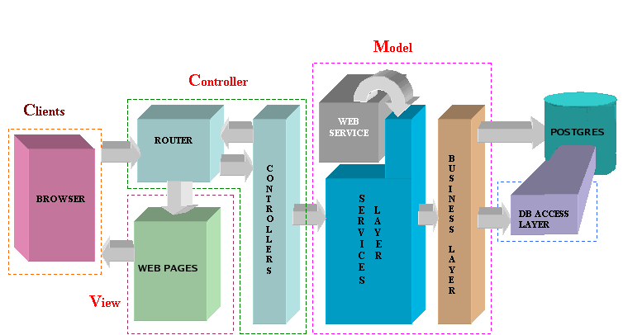It is common to split an application into separate layers: presentation (UI), domain, and data access. In MVC the presentation layer is further separated into View and Controller. MVC encompasses more of the architecture of an application than is typical for a design pattern.

**Model :**

The **domain**-specific representation of the information on which the application operates. It is a common misconception that the model is another name for the domain layer. Domain logic adds meaning to raw data (e.g., calculating if today is the user's birthday, or the totals, taxes and shipping charges for shopping cart items).Many applications use a persistent storage mechanism (such as a [database](http://en.wikipedia.org/wiki/Database)) to store data. MVC does not specifically mention the data access layer because it is understood to be underneath or encapsulated by the Model.

**View :**

Renders the model into a form suitable for interaction, typically a [user interface](http://en.wikipedia.org/wiki/User_interface) element. MVC is often seen in [web applications](http://en.wikipedia.org/wiki/Web_application), where the view is the [HTML](http://en.wikipedia.org/wiki/HTML) page and the code which gathers dynamic data for the page.

**Controller :**

Processes and responds to events, typically user actions, and may invoke changes on the model. Though MVC comes in different flavors, control flow generally works as follows:

1. The user interacts with the user interface in some way (e.g., user presses a button)
2. A controller handles the input event from the [user interface](http://en.wikipedia.org/wiki/User_interface), often via a registered [handler](http://en.wikipedia.org/wiki/Event_handler) or [callback](http://en.wikipedia.org/wiki/Callback_(computer_science)).
3. The controller accesses the model, possibly updating it in a way appropriate to the user's action (e.g., controller updates user's [shopping cart](http://en.wikipedia.org/wiki/Shopping_cart)).
4. A view uses the model to generate an appropriate user interface (e.g., view produces a screen listing the shopping cart contents). The view gets its own data from the model. The model has no direct knowledge of the view. (However, the [observer pattern](http://en.wikipedia.org/wiki/Observer_pattern) can be used to allow the model to indirectly notify interested parties – potentially including views – of a change.)
5. The user interface waits for further user interactions, which begins the cycle anew.

**The JAVA Technology :**

Java has a profound effect on a network as Java expands the universe of objects that can move about freely in cyberspace. Java can be termed as any other object oriented language but the fundamental forces that necessitated the invention of java are security and portability, though other factors played an important role in molding the final form of the language. Java can be described by the following buzzwords:-

1. Simple
2. Secure
3. Portable
4. Object-Oriented
5. Robust
6. Multithreaded
7. Architecture-neutral
8. Interpreted
9. High Performance
10. Distributed
11. Dynamic

**SERVLETS**

The Java web server is JavaSoft's own web Server. The Java web server is just a part of a larger framework, intended to provide you not just with a web server, but also with tools. To build customized network servers for any Internet or Intranet client/server system. Servlets are to a web server, how applets are to the browser.

**About Servlets**

Servlets provide a Java-based solution used to address the problems currently associated with doing server-side programming, including inextensible scripting solutions, platform-specific APIs, and incomplete interfaces.

Servlets are objects that conform to a specific interface that can be plugged into a Java-based server. Servlets are to the server-side what applets are to the client-side - object byte codes that can be dynamically loaded off the net. They differ from applets in that they are faceless objects (without graphics or a GUI component). They serve as platform independent, dynamically loadable, pluggable helper byte code objects on the server side that can be used to dynamically extend server-side functionality.

For example, an HTTP Servlets can be used to generate dynamic HTML content. When you use Servlets to do dynamic content you get the following advantages:

1. They’re faster and cleaner than CGI scripts
2. They use a standard API (the Servlets API)
3. They provide all the advantages of Java (run on a variety of servers without needing to be rewritten).

**Java Server Pages (JSP)**

Java server Pages is a simple, yet powerful technology for creating and maintaining dynamic-content web pages. Based on the Java programming language, Java Server Pages offers proven portability, open standards, and a mature re-usable component model .The Java Server Pages architecture enables the separation of content generation from content presentation. This separation not eases maintenance headaches; it also allows web team members to focus on their areas of expertise. Now, web page designer can concentrate on layout, and web application designers on programming, with minimal concern about impacting each other’s work.

**Features of JSP**

**Portability:**

Java Server Pages files can be run on any web server or web-enabled application server that provides support for them. Dubbed the JSP engine, this support involves recognition, translation, and management of the Java Server Page lifecycle and its interaction components.

**Components**

It was mentioned earlier that the Java Server Pages architecture can include reusable Java components. The architecture also allows for the embedding of a scripting language directly into the Java Server Pages file. The components current supported include Java Beans, and Servlets.

**Processing**

A Java Server Pages file is essentially an HTML document with JSP scripting or tags. The Java Server Pages file has a JSP extension to the server as a Java Server Pages file. Before the page is served, the Java Server Pages syntax is parsed and processed into a Servlet on the server side. The Servlet that is generated outputs real content in straight HTML for responding to the client.

**Access Models:**

A Java Server Pages file may be accessed in at least two different ways. A client’s request comes directly into a Java Server Page. In this scenario, suppose the page accesses reusable Java Bean components that perform particular well-defined computations like accessing a database. The result of the Beans computations, called result sets is stored within the Bean as properties. The page uses such Beans to generate dynamic content and present it back to the client.

In both of the above cases, the page could also contain any valid Java code. Java Server Pages architecture encourages separation of content from presentation.

Steps in the execution of a JSP Application:

1. The client sends a request to the web server for a JSP file by giving the name of the JSP file within the form tag of a HTML page.
2. This request is transferred to the JavaWebServer. At the server side JavaWebServer receives the request and if it is a request for a jsp file server gives this request to the JSP engine.
3. JSP engine is program which can understands the tags of the jsp and then it converts those tags into a Servlet program and it is stored at the server side. This Servlet is loaded in the memory and then it is executed and the result is given back to the JavaWebServer and then it is transferred back to the result is given back to the JavaWebServer and then it is transferred back to the client.

**PRODUCT FUNCTIONS:**

* New Applicants do registration for the application of voter id. when

They are verified only then voter card is issued by the Commissioner Officer then

Voter id.

* Registered Applicant as Voter can apply for password. They can also apply to

Change the password and address. They can view Candidate information.

* The election commission will be able to use the site to let the candidates register

for their nomination on the site and their officers will validate it. Candidates can

run their election campaign through forums and chat-room.

* A detailed profile of all the candidates, constituency , district, state wise will be

maintained so that voters can always know about the candidates of their area.

* Field Officer whose time period expired can apply for new appointment.
* Candidates will be able to modify selected portions of their profile after

registration for nomination like the promises they make about the things to do

after winning the election, their previous works, their experiences and a

comprehensive about me, etc.

* Election Commissioner can update and upload their profile. They can view all

Applications. They issued voter card , publish vote result, appoint new field

Officer.

**USER CHARACTERISTICS:**

* Every user should be comfortable of working with computer and net browsing.
* Every user must have basic knowledge of English too.

**CONSTRAINTS:**

* GUI is only in English.
* This system is working for single server.
* Limited to HTTP/HTTPS.

**ASSUMPTIONS AND DEPENDENCIES:**

* The end user should have a basic knowledge of English and computer usage.
* Administrator is created in the system already.
* The voting results will be calculated by the administrator manually.
* Roles and tasks are predefined.

APPLICATION DEVELOPMENT

N-TIER APPLICATIONS

N-Tier Applications easily implements the concepts of Distributed Application Design and

Architecture. The N-Tier Applications provide strategic benefits to Enterprise Solutions.

While 2-tier, client-server can help us create quick and easy solutions and may be used for

Rapid Prototyping, they can easily become a maintenance and security night mare

The N-tier Applications provide specific advantages that are vital to the business continuity

of the enterprise. Typical features of a real life n-tier may include the following:

* Security
* Availability and Scalability
* Manageability
* Easy Maintenance
* Data Abstraction

The above mentioned points are some of the key design goals of a successful n-tier

application that intends to provide a good Business Solution.

**DEFINITION**

Simply stated, an n-tier application helps us to distribute the overall functionality into various

tiers or layers:

* Presentation Layer
* Business Rules Layer
* Data Access Layer
* Database/Data Store

Each layer can be developed independently of the other provided that it adheres to the

standards and communicates with the other layers as per the specifications.

This is the one of the biggest advantages of the n-tier application. Each layer can potentially

treat the other layer as a ‘Block-Box’.

In other words, each layer does not care how other layer processes the data as long as it sends

the right data in a correct format.

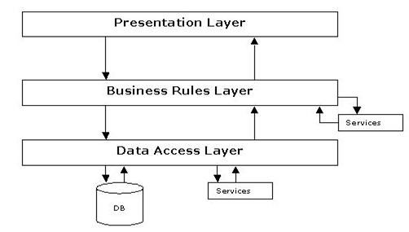

**Fig 1.1-N-Tier Architecture**

1. **THE PRESENTATION LAYER**

Also called as the client layer comprises of components that are dedicated to

presenting the data to the user. For example: Windows/Web Forms and buttons, edit

boxes, Text boxes, labels, grids, etc.

1. **THE BUSINESS RULES LAYER**

This layer encapsulates the Business rules or the business logic of the encapsulations.

To have a separate layer for business logic is of a great advantage. This is because any

changes in Business Rules can be easily handled in this layer. As long as the interface

between the layers remains the same, any changes to the functionality/processing

logic in this layer can be made without impacting the others. A lot of client-server

apps failed to implement successfully as changing the business logic was a painful

process.

1. **THE DATA ACCESS LAYER**

This layer comprises of components that help in accessing the Database. If used in the

right way, this layer provides a level of abstraction for the database structures. Simply

put changes made to the database, tables, etc do not affect the rest of the application

because of the Data Access layer. The different application layers send the data

requests to this layer and receive the response from this layer.

1. **THE DATABASE LAYER**

This layer comprises of the Database Components such as DB Files, Tables, Views,

etc. The Actual database could be created using DB2 Server, Flat files, etc.

In an n-tier application, the entire application can be implemented in such a way that

it is independent of the actual Database. For instance, you could change the Database

Location with minimal changes to Data Access Layer. The rest of the Application

DEVELOPMENT METHODOLOGY

SPIRAL MODEL SOFTWARE

**SDLC METHDOLOGIES :**

This document play a vital role in the development of life cycle (SDLC) as it describes the

complete requirement of the system. It means for use by developers and will be the basic

during testing phase. Any changes made to the requirements in the future will have to go

through formal change approval process.

SPIRAL MODEL was defined by Barry Boehm in his 1988 article, “A spiral Model of

Software Development and Enhancement. This model was not the first model to discuss

iterative development, but it was the first model to explain why the iteration models.

As originally envisioned, the iterations were typically 6 months to 2 years long. Each

phase starts with a design goal and ends with a client reviewing the progress thus far.

Analysis and engineering efforts are applied at each phase of the project, with an eye

toward the end goal of the project.

The steps for Spiral Model can be generalized as follows:

* The new system requirements are defined in as much details as possible. This

usually involves interviewing a number of users representing all the external or

internal users and other aspects of the existing system.

* A preliminary design is created for the new system.
* A first prototype of the new system is constructed from the preliminary design.

This is usually a scaled-down system, and represents an approximation of the

characteristics of the final product.

* A second prototype is evolved by a fourfold procedure:

1. Evaluating the first prototype in terms of its strengths, weakness, and risks.
2. Defining the requirements of the second prototype.
3. Planning an designing the second prototype.
4. Constructing and testing the second prototype.

* At the customer option, the entire project can be aborted if the risk is deemed too

great. Risk factors might involved development cost overruns, operating-cost

miscalculation, or any other factor that could, in the customer’s judgment, result

in a less-than-satisfactory final product.

* The existing prototype is evaluated in the same manner as was the previous

prototype, and if necessary, another prototype is developed from it according to

the fourfold procedure outlined above.

* The preceding steps are iterated until the customer is satisfied that the refined

prototype represents the final product desired.

* The final system is constructed, based on the refined prototype.
* The final system is thoroughly evaluated and tested. Routine maintenance is

carried on a continuing basis to prevent large scale failures and to minimize down

time.

**The following diagram shows how a spiral model acts like:**

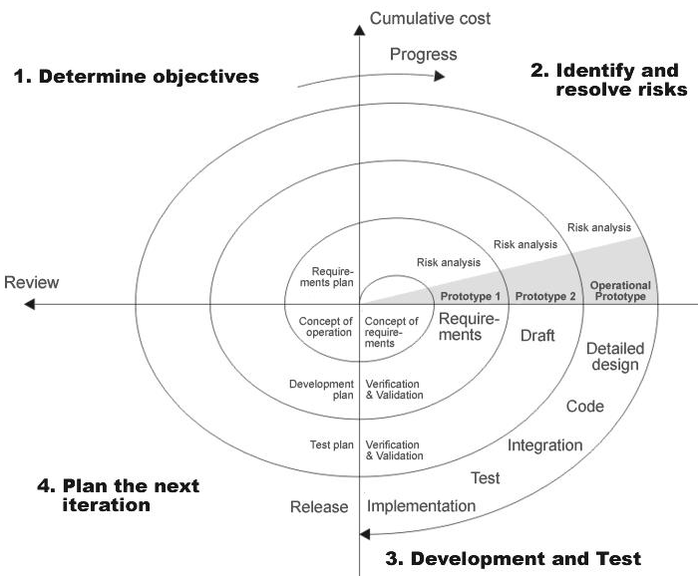

**Fig 1.0-Spiral Model**

**ADVANTAGES**

* Estimates(i.e. budget, schedule etc .) become more relistic as work progresses, because important issues discoved earlier.
* It is more able to cope with the changes that are software development generally entails.
* Software engineers can get their hands in and start woring on the core of a project earlier.

SYSTEM DESIGN

E-R DIAGRAM

Database management system is not only the way of organizing data in the memory

But it also gives the relationship between different elements. Database is used to store

data and at any stage data can be retrieved from it as per need.

There are two models of representing database-

* 1. Relational model.
  2. Entity-relationship model

Entity relationship model represents the real world. It is based on objects.

Graphical representation of entity relationship model is called E-R diagram

Entity: It represents the object in the real world. Each Entity has its attribute.

Entity-Set: It is the group of all the entities having same attributes.

Relationship: Each entity in E-R model linked with each other through certain

Relationship.

Relationship-set: It represents the set of all entity that used to established relation

Between different entities.

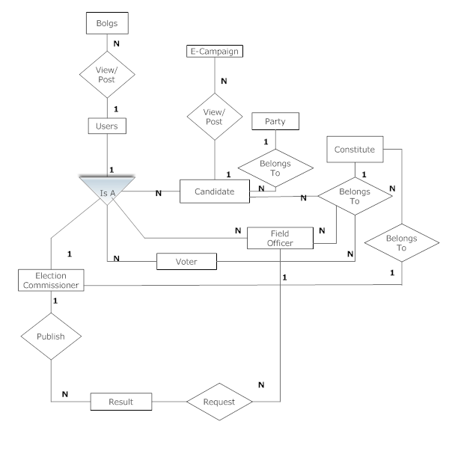

Entity-

Relation -

Specialization-

ISA

Attributes-

DATA FLOW DIAGRAMS

A data flow diagram is graphical tool used to describe and analyze movement of data through a system. These are the central tool and the basis from which the other components are developed. The transformation of data from input to output, through processed, may be described logically and independently of physical components associated with the system.

UML DIAGRAM

CLASS DIAGRAM

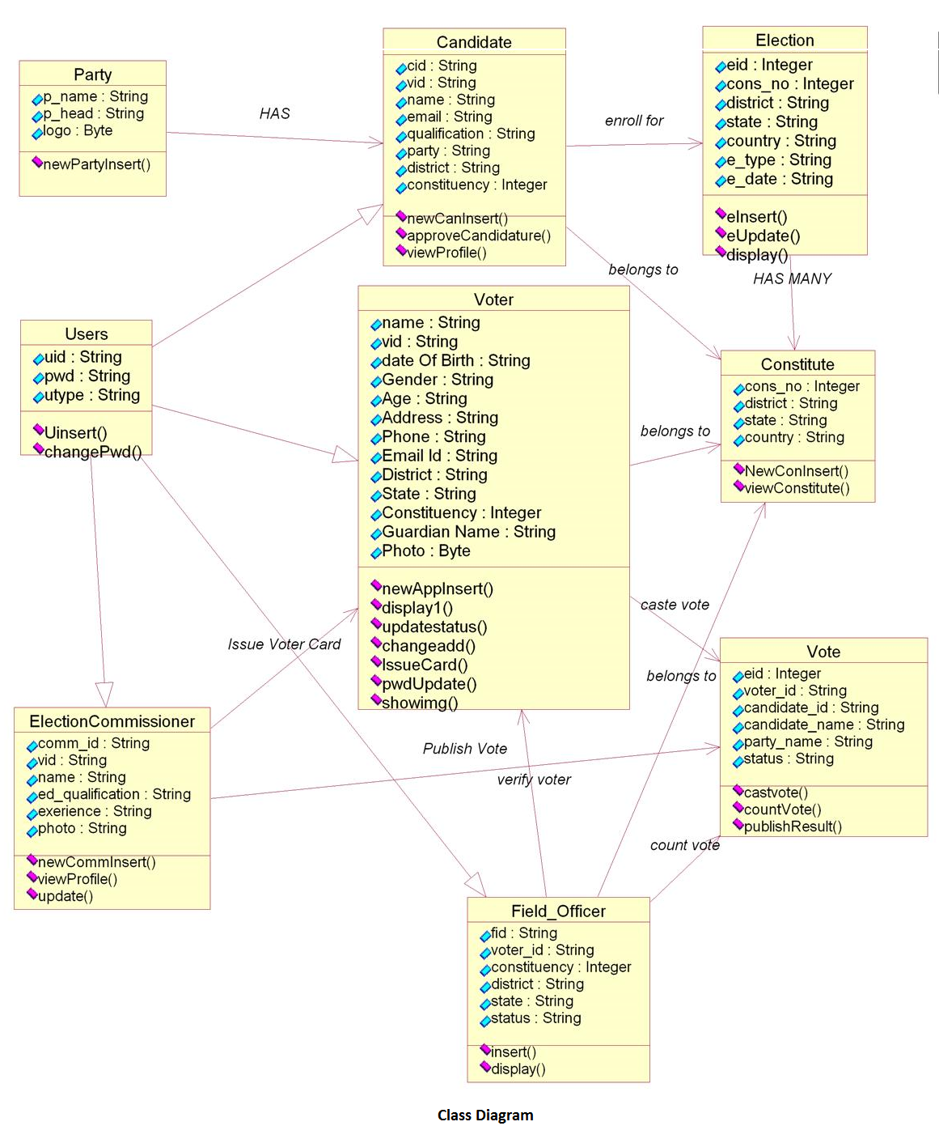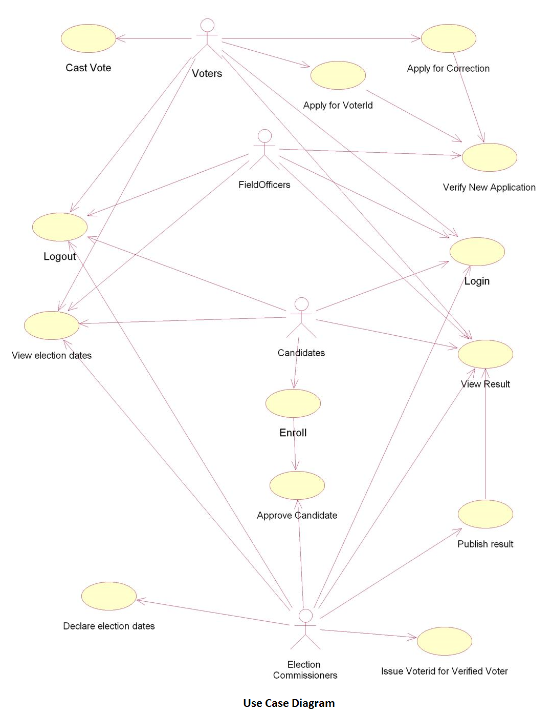

USECASE DIAGRAM

SEQUENTIAL AND COLLABRATION DIAGRAM FOR CASTING VOTE

**

Sequence Diagram of verification of Voter

Collaboration Diagram of Verification of Voter



Sequence Diagram of Casting Vote



Collaboration Diagram Of Casting Vote



Sequence Diagram Of Polling Result



Collaboration of Polling Result



DATABASE STRUCTURE

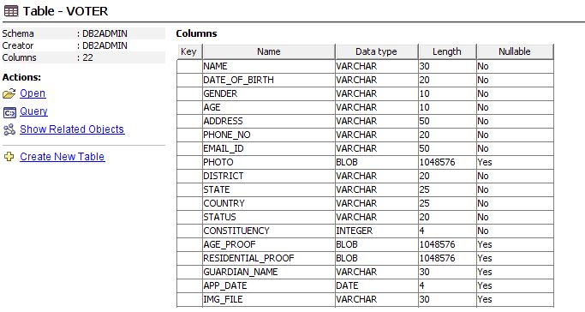

INSERT INTO VOTER VALUES (“RIMA ROY”,”11-02-1987”,”FEMALE”,37,”GHARAUNDA ENCLAVE”,8765093478,[rror@gmail.com](mailto:rror@gmail.com),”r.JPEG”,”GANDHINAGAR”,”GUJARAT”,”INDIA”,”Applied”,12,”p.JPEG”,”age.JPEG”,”RISHI”,10-07-2014)

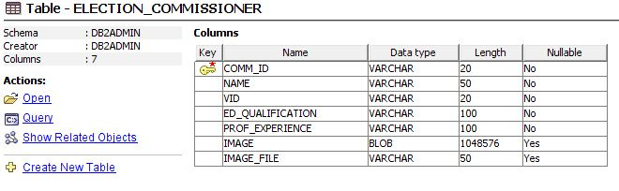

Update ELECTION_COMMISSIONER set ED_QUALIFICATION=”Ph.D“, PROF_EXPERIENE=”MAJOR” ,IMAGE_FILE=”P.JPEG”

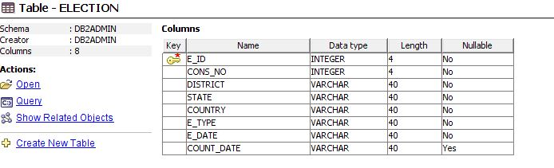

Select E_ID from ELECTION where CONS_NO=12 and DISTRICT=”GANDHINAGAR” and E_DATE= “CURRENT DATE”

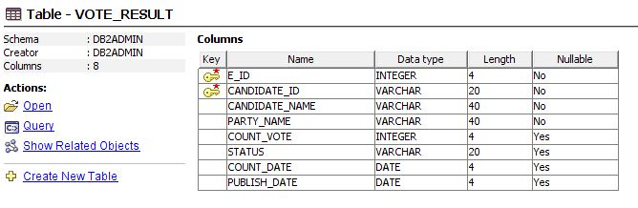

Select COUNT_VOTE from VOTE_RESULT

**TESTING**

**Testing Concepts**

* ***Testing***
* ***Testing Methodologies***
* Black box Testing:
* White box Testing.
* Gray Box Testing.
* ***Levels of Testing***
  + Unit Testing.
  + Module Testing.
  + Integration Testing.
  + System Testing.
  + User Acceptance Testing.

**Testing:**

* The process of executing a system with the intent of finding an error.
* Testing is defined as the process in which defects are identified, isolated, subjected for rectification and ensured that product is defect free in order to produce the quality product and hence customer satisfaction.
* Quality is defined as justification of the requirements
* Defect is nothing but deviation from the requirements
* Defect is nothing but bug.
* Testing --- The presence of bugs
* Testing can demonstrate the presence of bugs, but not their absence
* Debugging and Testing are not the same thing!
* Testing is a systematic attempt to break a program or the AUT
* Debugging is the art or method of uncovering why the script /program did not execute properly.

**Testing Methodology used:**

* **White box Testing**: is the testing process in which tester can perform testing on an application with having internal structural knowledge.

Usually The Developers are involved in white box testing.

**Levels of Testing:**

|  |  |  |  |  |  |  |  |  |  |  |  |  |  |  |  |
| --- | --- | --- | --- | --- | --- | --- | --- | --- | --- | --- | --- | --- | --- | --- | --- |
| |  |  |  |  |  |  |  |  |  |  |  |  |  |  |  | | --- | --- | --- | --- | --- | --- | --- | --- | --- | --- | --- | --- | --- | --- | --- | | ***Module1*** ***Module2*** ***Module3***   |  |  |  |  |  |  |  |  |  |  |  |  |  |  | | --- | --- | --- | --- | --- | --- | --- | --- | --- | --- | --- | --- | --- | --- | | ***Units***   |  |  |  | | --- | --- | --- | |  |  |  | |  | ***Units***   |  |  |  | | --- | --- | --- | |  |  |  | |  | ***Units***   |  |  |  | | --- | --- | --- | |  |  |  | |   i/p ***Integration***  o/p i/p ***Integration o/p*** |   ***System Testing: Presentation + business +Databases***  ***🚹UAT: user acceptance testing*** |

##### STLC (SOFTWARE TESTING LIFE CYCLE)

**Test Planning:**

* 1. Test Plan is defined as a strategic document which describes the procedure how to perform various testing on the total application in the most efficient way.
  2. This document involves the scope of testing,
  3. Objective of testing
  4. Areas that need to be tested
  5. Areas that should not be tested
  6. Scheduling Resource Planning
  7. Areas to be automated, various testing tools

Used….

**Test Development**:

**1.** Test case Development (check list)

**2.** Test Procedure preparation. (Description of the Test cases).

**3.** Implementation of test cases. Observing the result.

**Result Analysis**: **1.** Expected value: is nothing but expected behavior

Of application.

**2.** Actual value: is nothing but actual behavior of

application

**Bug Tracing:**  Collect all the failed cases, prepare documents.

**Reporting:** Prepare document (status of the application

**FUTURE ENHANCEMENTS**

It is not possible to develop a system that makes all the requirements of the user. User requirements keep changing as the system is being used. Some of the future enhancements that can be done to this system are:

* As the technology emerges, it is possible to upgrade the system and can be adaptable to desired environment.
* Because it is based on object-oriented design, any further changes can be easily adaptable.
* Based on the future security issues, security can be improved using emerging technologies.
* Election module, result module can be enhanced

**CONCLUSION**

This system online national polling is introduced for maintaining polling with effectively and efficiently by introducing security, authentication, introducing zones, constituencies ,employee details, users profiles, party details ,election details and releasing election results efficiently to user with the help of the this automated application ,in this organization field officers play very important role to manage polling system.

BIBLIOGRAPHY

* WebSphere Application Server on Developer Works- <http://www.ibm.com/developerworks/websphere/zones/was/>

* AST 6.1 Development tool for WebSphere Software- <http://www.ibm.com/developerworks/rational/products/ast/>
* WebSphere Integration Developer- <http://www.ibm.com/developerworks/websphere/zones/businessintegration/wps/wps.html>
* IBM DB2- http://www.ibm.com/developerworks
* Java Complete Reference By Herbert Shield
* Database Programming with JDBC and Java By George Reese
* Wikipedia, URL: <http://www.wikipedia.org>.
* Answers.com, Online Dictionary, Encyclopedia and much more, URL: <http://www.answers.com>
* Google, URL: <http://www.google.co.in>
* Project Management URL: <http://www.startwright.com/project.htm>
* There are various automated tools for Database Maintenance, a

place to get help from could be

_

http://www106.ibm.com/developerworks/db2/library/techarticle/0

308chong/0308chong.html

**PROJECT MODULE DESCRIPTION**

1. **HOME PAGE FOR USERS:**

It’s the home of Online national polling project ,so the users are requested to go through the provided home page to log in.

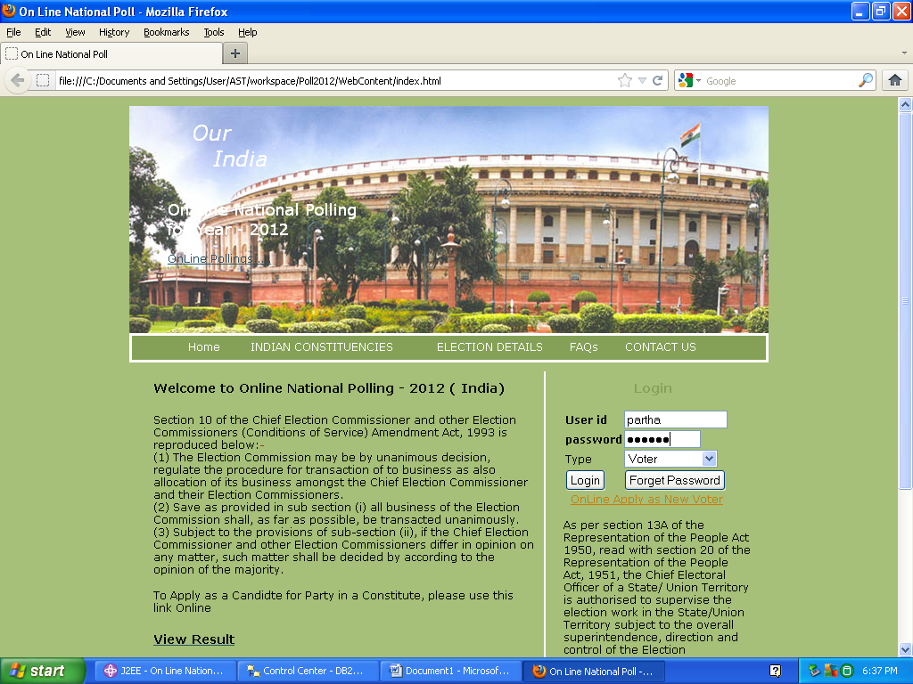

1. **VOTER REGISTRATION FORM:**

18 + adults those who will be going through the voting procedure for the first time are requested to fill up the registration form to entitle themselves as the legal voter for online polling.

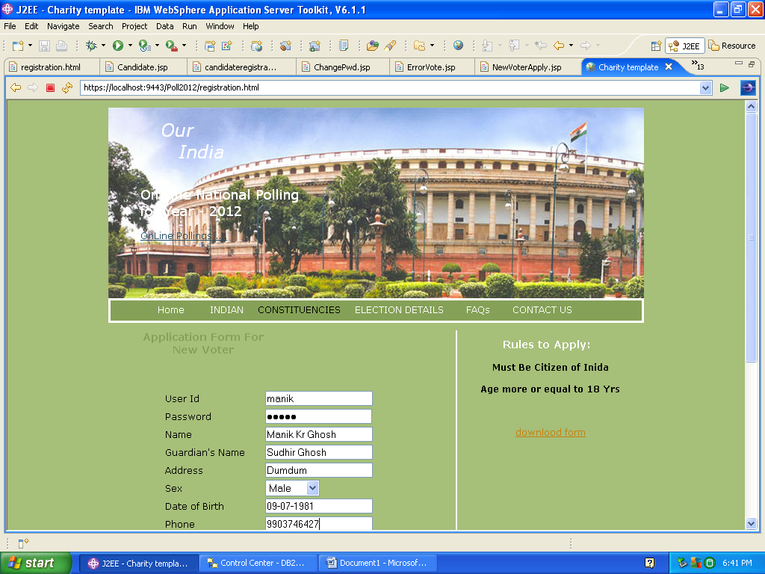

1. **CANDIDATE REGISTRATION FORM:**

Interested candidates are requested to fill up the candidate registration form before standing as a candidate for the election. It is an essential and initial stage before applying as a candidate for the election.

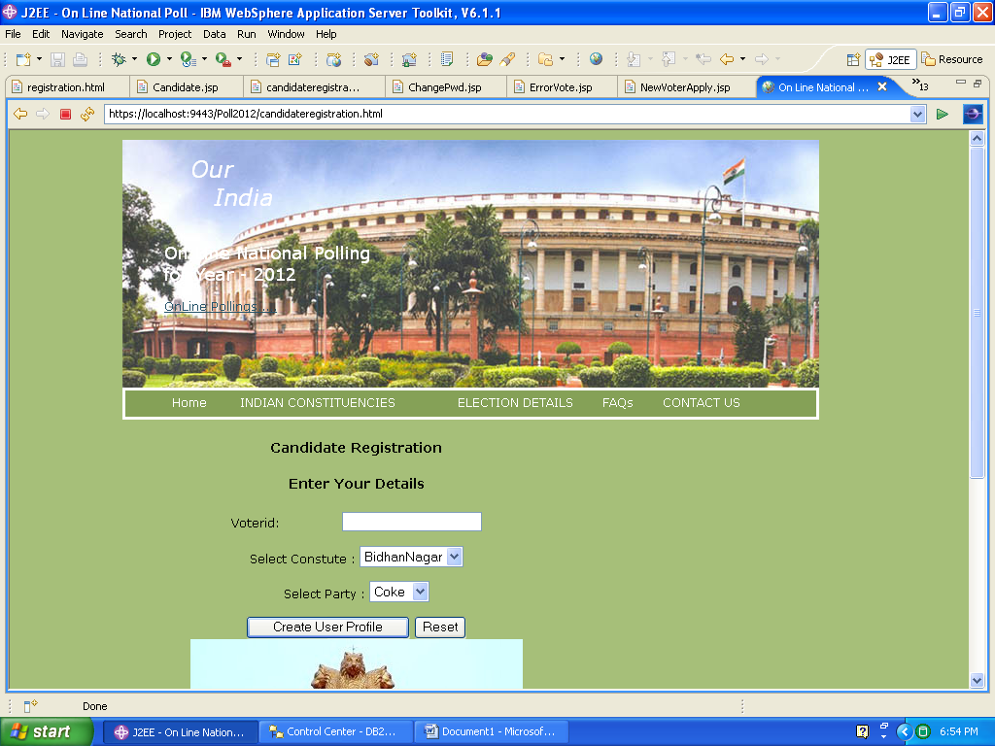

1. **ELECTION COMMISSIONER PROFILE PAGE:**

It is a personal profile page for the election commissioner through which he /she can perform their work moreover this page also helps him/her to control the entire election procedure.

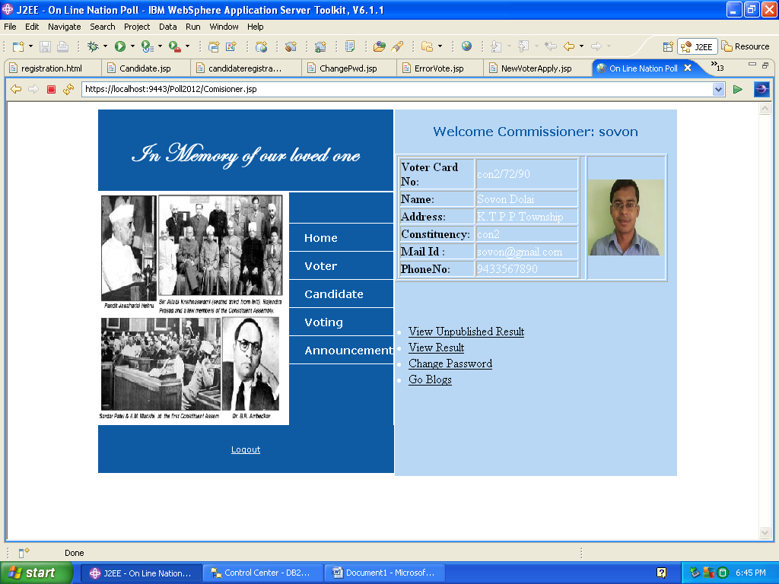

1. **FIELD OFFICER PROFILE PAGE:**

It is a personal profile page for field officer through which he/she can perform the assigned duties.

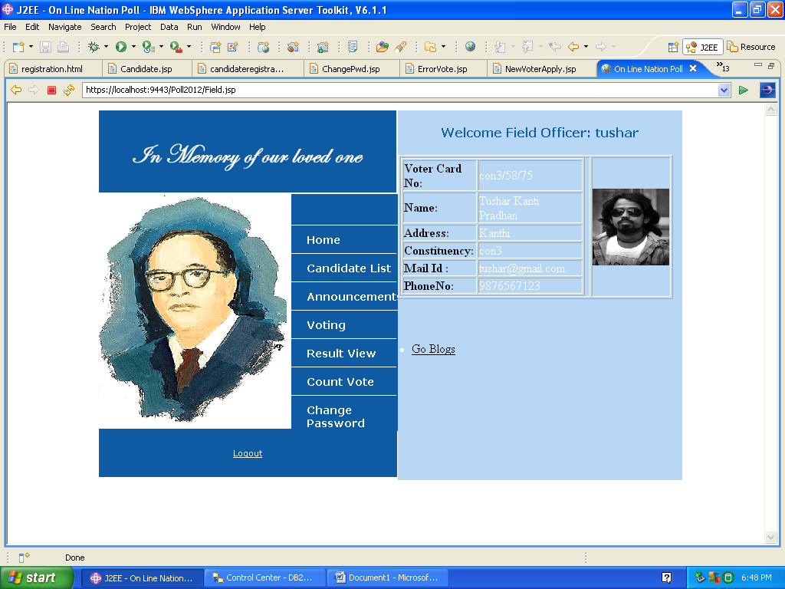

1. **VOTER PROFILE PAGE:**

It’s a profile page for voter’s through which they can keep on updating themselves and go through their personal details at any time. Through this page they can participate themselves as a voter in the voting procedure and check out the candidate and party list easily.

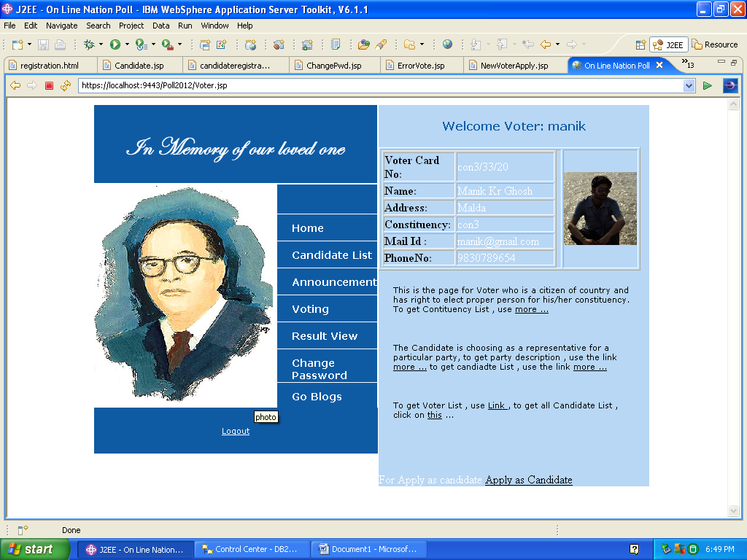

1. **CANDIDATE PROFILE PAGE:**

It’s a profile page for candidates through which they can keep on updating themselves and go through their personal details at any time. Through this page the candidates can give vote and go through the other candidate details.

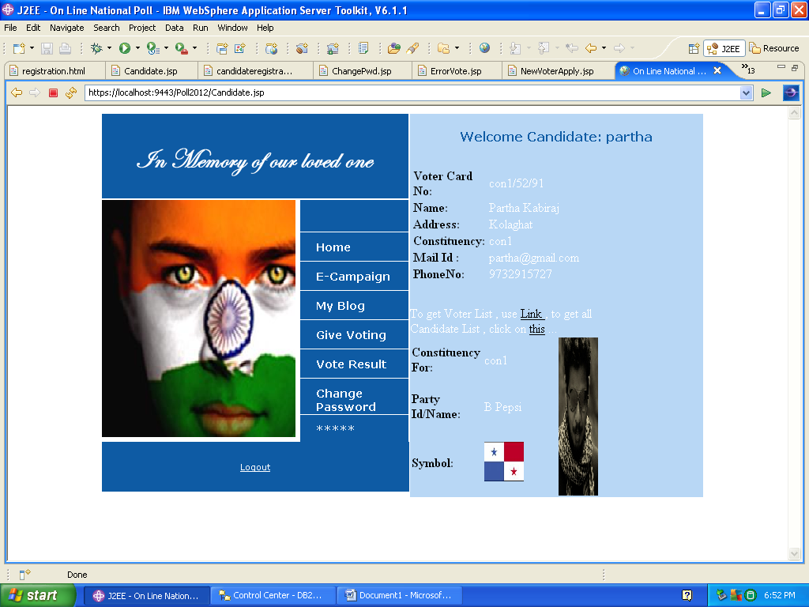

1. **VOTERLIST PAGE:**

Users are entitled to see the voter list provided below,

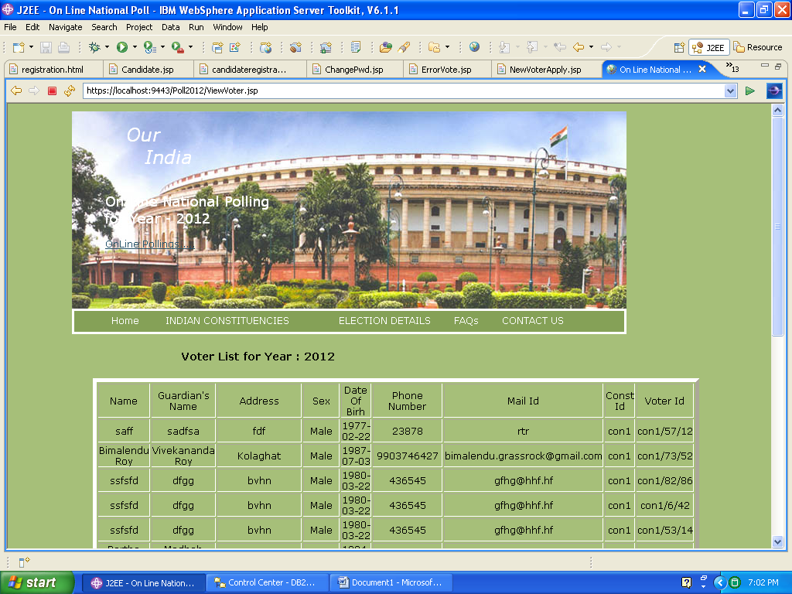

1. **CANDIDATE LIST PAGE:**

Users those who are using this system are entitled to see the candidate list and available parties as well as they can also check out that which candidate is standing on behalf of which party.

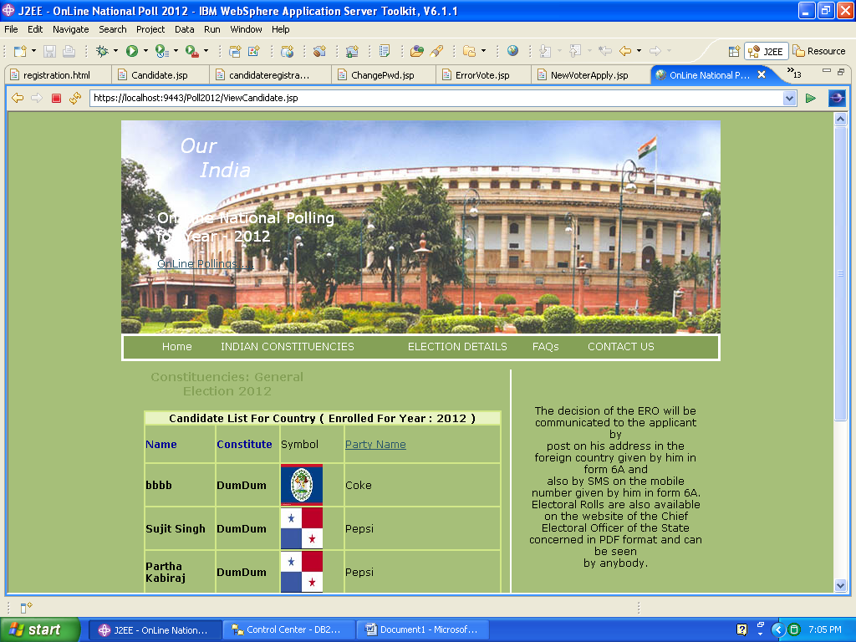

1. **CONSTITUENCIES DETAILS:**

Users are also entitled to go through the various constitutions of various states under a nation.

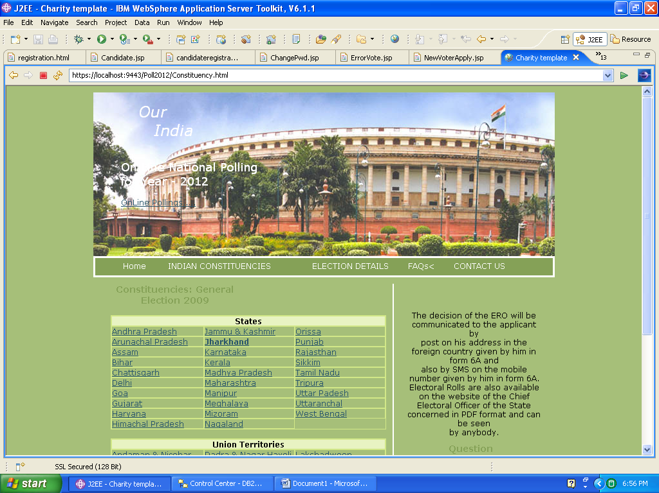

1. **PARTY LIST:**

Users can go through this page to check out the available parties in the voting poll and they can also collect the required details of the parties.

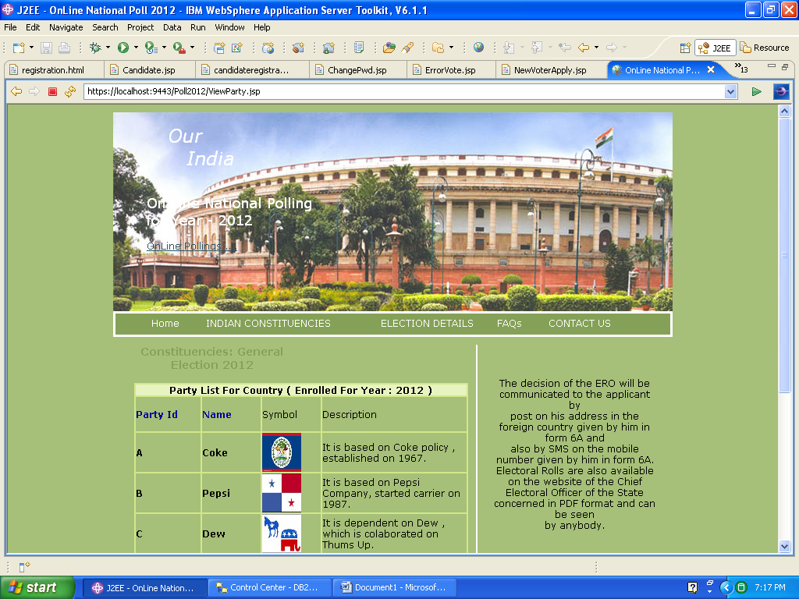

1. **CHANGE PASSWORD PAGE:**

Interested users are opt with a page from where they can change their personal passwords for the sake of security purpose.

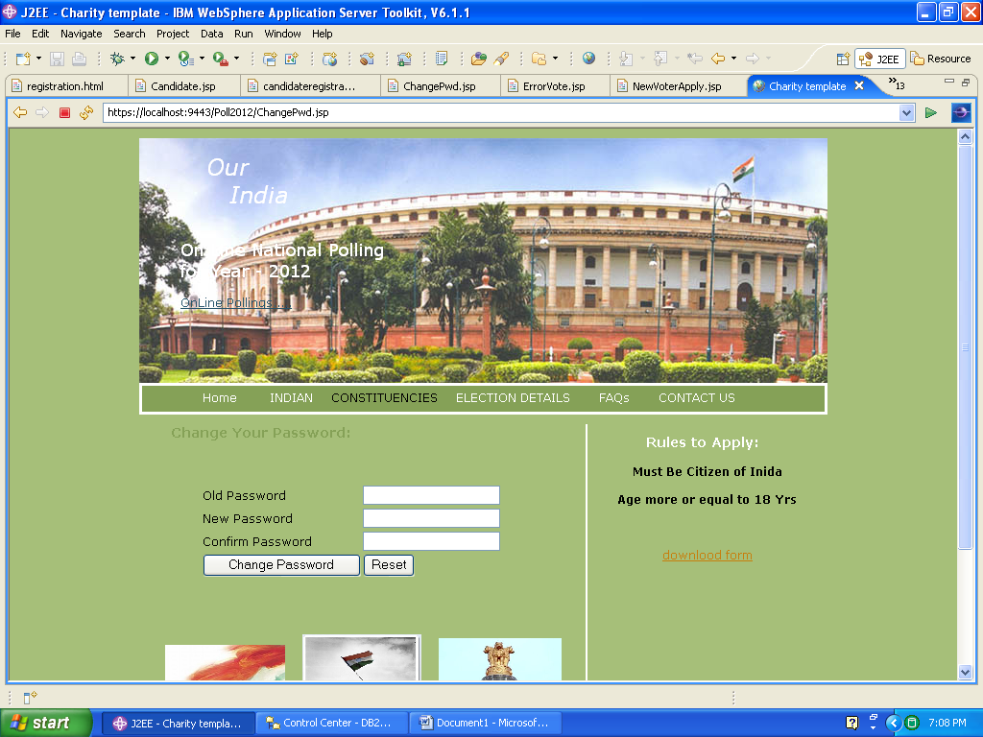

1. **VOTING DATE DECLARATION PAGE:**

By this page only the election commissioner can schedule the election dates which is informative for the users.

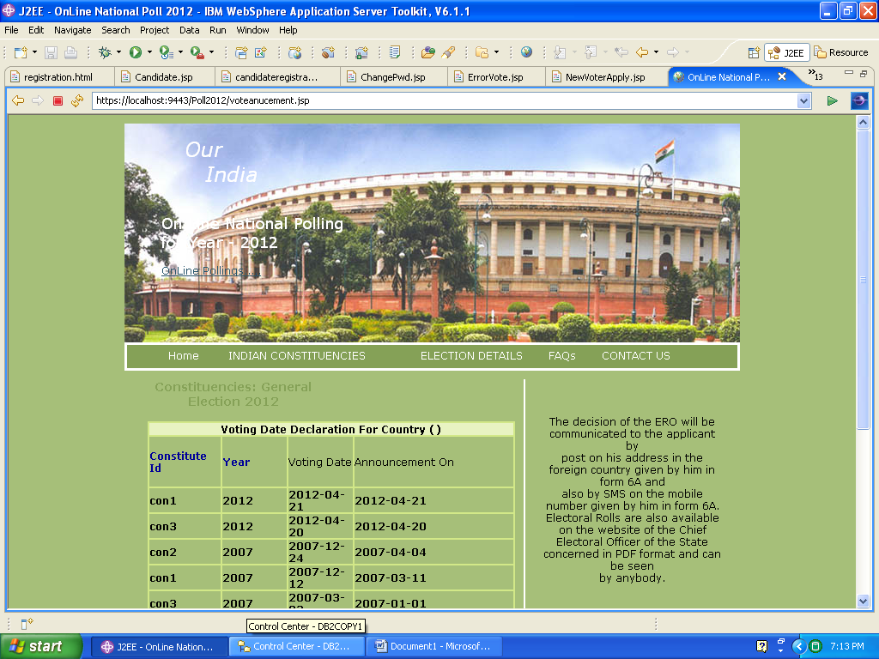

1. **GIVE VOTE:**

Voters can give their votes only through the page which is prescribed below.

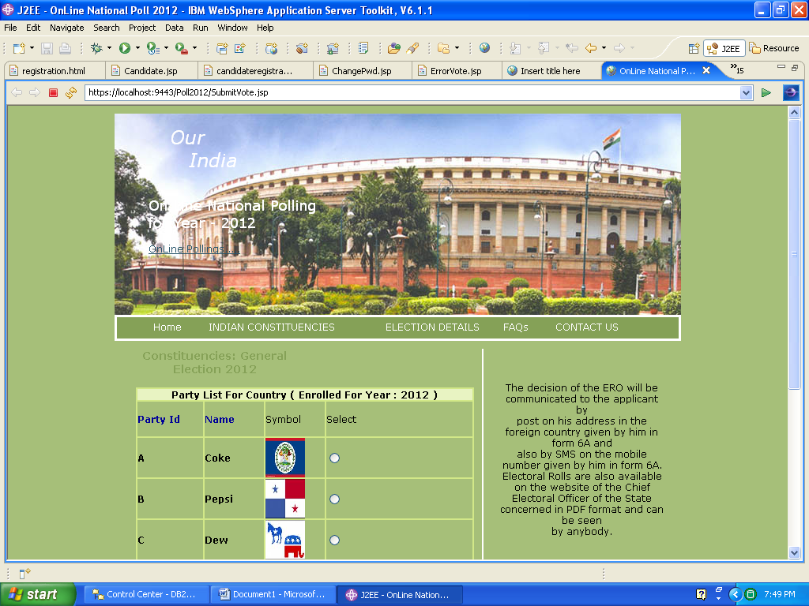

1. **VIEW RESULT:**

After the completion of the total voting procedure, the users can check out the result of the vote through this page.

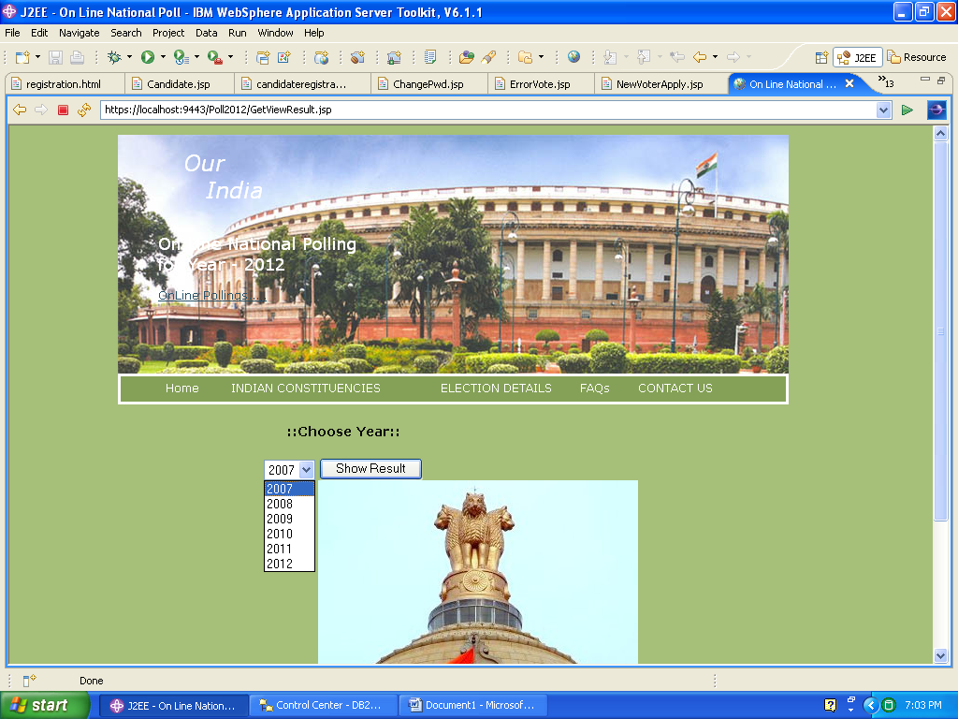

1. **VIEW BLOGS:**

It’s a mare social page through which the users can give their comments based on the polling as well as they can check the blogs.

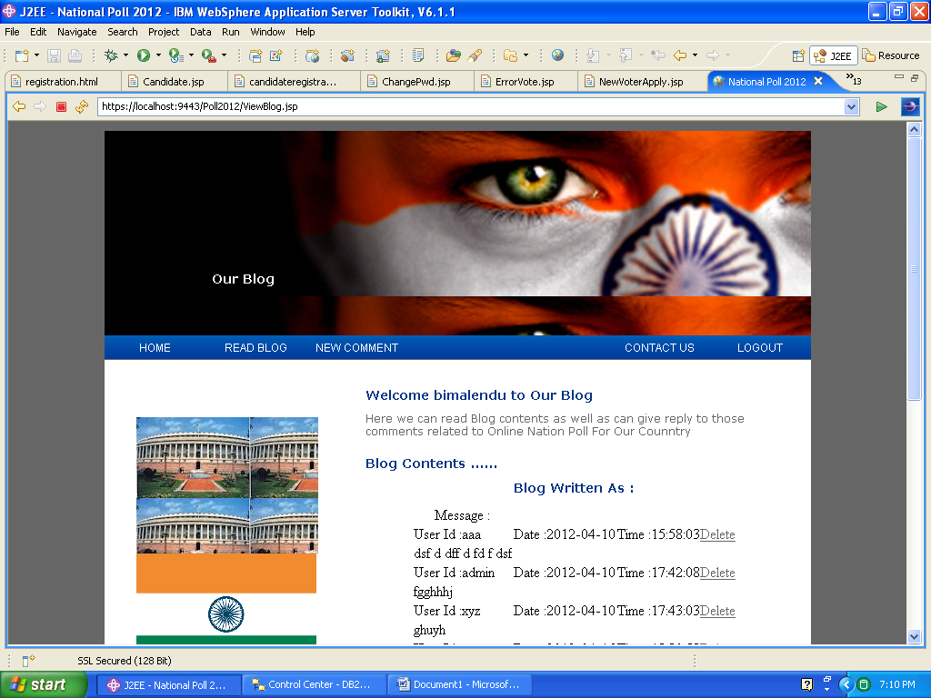

1. **FAQ PAGE:**

Users are always curious, regarding various details in respect of the polling procedure therefore a FAQ page is provided to sort out various questions of the users.

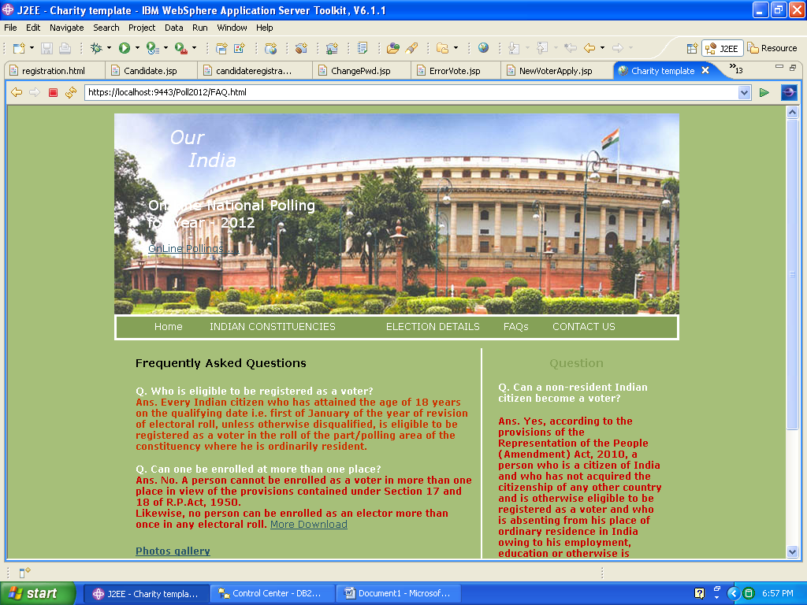

1. **CONTACT US PAGE:**

For further details users can directly clarify their doubts by connecting themselves with election commission through this page.

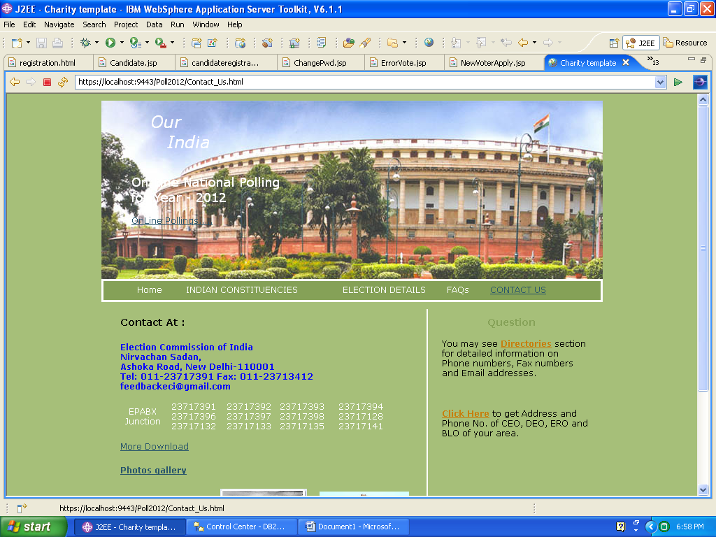

**TESTING**

**Testing Concepts**

* ***Testing***
* ***Testing Methodologies***
* Black box Testing:
* White box Testing.
* Gray Box Testing.
* ***Levels of Testing***
  + Unit Testing.
  + Module Testing.
  + Integration Testing.
  + System Testing.
  + User Acceptance Testing.

**Testing:**

* The process of executing a system with the intent of finding an error.
* Testing is defined as the process in which defects are identified, isolated, subjected for rectification and ensured that product is defect free in order to produce the quality product and hence customer satisfaction.
* Quality is defined as justification of the requirements
* Defect is nothing but deviation from the requirements
* Defect is nothing but bug.
* Testing --- The presence of bugs
* Testing can demonstrate the presence of bugs, but not their absence
* Debugging and Testing are not the same thing!
* Testing is a systematic attempt to break a program or the AUT
* Debugging is the art or method of uncovering why the script /program did not execute properly.

**Testing Methodology used:**

* **White box Testing**: is the testing process in which tester can perform testing on an application with having internal structural knowledge.

Usually The Developers are involved in white box testing.

**Levels of Testing:**

|  |  |  |  |  |  |  |  |  |  |  |  |  |  |  |  |
| --- | --- | --- | --- | --- | --- | --- | --- | --- | --- | --- | --- | --- | --- | --- | --- |
| |  |  |  |  |  |  |  |  |  |  |  |  |  |  |  | | --- | --- | --- | --- | --- | --- | --- | --- | --- | --- | --- | --- | --- | --- | --- | | ***Module1*** ***Module2*** ***Module3***   |  |  |  |  |  |  |  |  |  |  |  |  |  |  | | --- | --- | --- | --- | --- | --- | --- | --- | --- | --- | --- | --- | --- | --- | | ***Units***   |  |  |  | | --- | --- | --- | |  |  |  | |  | ***Units***   |  |  |  | | --- | --- | --- | |  |  |  | |  | ***Units***   |  |  |  | | --- | --- | --- | |  |  |  | |   i/p ***Integration***  o/p i/p ***Integration o/p*** |   ***System Testing: Presentation + business +Databases***  ***🚹UAT: user acceptance testing*** |

##### STLC (SOFTWARE TESTING LIFE CYCLE)

**Test Planning:**

* 1. Test Plan is defined as a strategic document which describes the procedure how to perform various testing on the total application in the most efficient way.
  2. This document involves the scope of testing,
  3. Objective of testing
  4. Areas that need to be tested
  5. Areas that should not be tested
  6. Scheduling Resource Planning
  7. Areas to be automated, various testing tools

Used….

**Test Development**:

**1.** Test case Development (check list)

**2.** Test Procedure preparation. (Description of the Test cases).

**3.** Implementation of test cases. Observing the result.

**Result Analysis**: **1.** Expected value: is nothing but expected behavior

Of application.

**2.** Actual value: is nothing but actual behavior of

application

**Bug Tracing:**  Collect all the failed cases, prepare documents.

**Reporting:** Prepare document (status of the application

**FUTURE ENHANCEMENTS**

It is not possible to develop a system that makes all the requirements of the user. User requirements keep changing as the system is being used. Some of the future enhancements that can be done to this system are:

* As the technology emerges, it is possible to upgrade the system and can be adaptable to desired environment.
* Because it is based on object-oriented design, any further changes can be easily adaptable.
* Based on the future security issues, security can be improved using emerging technologies.
* Election module, result module can be enhanced

**CONCLUSION**

This system online national polling is introduced for maintaining polling with effectively and efficiently by introducing security, authentication, introducing zones, constituencies ,employee details, users profiles, party details ,election details and releasing election results efficiently to user with the help of the this automated application ,in this organization field officers play very important role to manage polling system.

**BIBLIOGRAPHY**

* WebSphere Application Server on Developer Works- <http://www.ibm.com/developerworks/websphere/zones/was/>

* AST 6.1 Development tool for WebSphere Software- <http://www.ibm.com/developerworks/rational/products/ast/>
* WebSphere Integration Developer- <http://www.ibm.com/developerworks/websphere/zones/businessintegration/wps/wps.html>
* IBM DB2- http://www.ibm.com/developerworks
* Java Complete Reference By Herbert Shield
* Database Programming with JDBC and Java By George Reese
* Wikipedia, URL: <http://www.wikipedia.org>.
* Answers.com, Online Dictionary, Encyclopedia and much more, URL: <http://www.answers.com>
* Google, URL: <http://www.google.co.in>
* Project Management URL: <http://www.startwright.com/project.htm>
* There are various automated tools for Database Maintenance, a

place to get help from could be

_

http://www106.ibm.com/developerworks/db2/library/techarticle/0

308chong/0308chong.html